Abdullahi Mohamed - M00810926
Middlesex University, London
Coursework 3: Individual Coursework (Part 2)

Question 1: First Scenario
1a) For the organization used for the previous coursework (Individual – Part 1): identify the stakeholders and identify what their priorities are (in this context you will not have the time to do proper stakeholder engagement activities, such as questionnaires and interviews so your best option is to find out in the literature and market studies published). (5 marks)

Stakeholders 1: Healthcare providers including doctors, nurses and health professionals (employees)

To find patient information, work effectively, reduce stress of patients and ensure minimal disturbance in daily workflow of task.
Stakeholders 2: Patients (customers)
Access health record, book appointments and communicate with healthcare providers.
Stakeholders 3: Healthcare Manager
Reduce cost from all processes, understand performance analytics, ensure operations is efficient and optimise resources.
Stakeholder 4: IT Department
To make sure system is secure, maintainable to use, listen to customer feedback and improve systems daily.
Stakeholder 5: Government
The healthcare regulation must be compliant with the law, produce financial report and quality metric of healthcare outcomes.
Stakeholder 6: Developers
The developers need to meet client requirements, maintain and update system.
1b) Draw up a business process model diagram describing the system and use text to describe an operational scenario illustrating how the system works. State any assumptions that you make. Hint: first identify the stakeholders, then the processes (try to aim for 20), then identify input and output data from the processes before drawing up the business process model. (15 marks)
Business Process Model for Healthcare Organisations
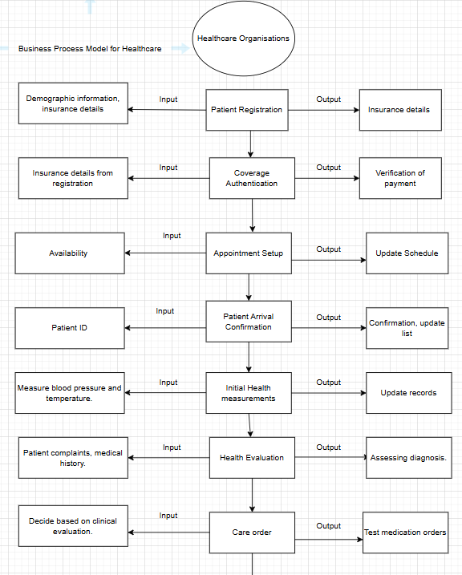
Figure 1 - Healthcare Business Process Model 1/3
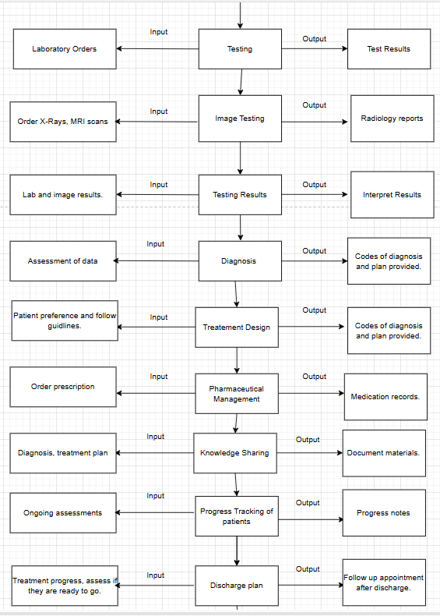
Figure 2 - Healthcare Business Process Model 2/3
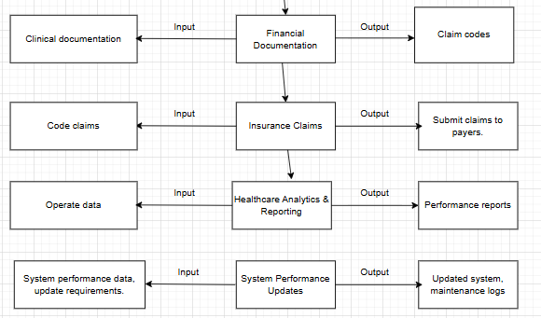
Figure 3 - Healthcare Business Process Model 3/3

Assumptions of Healthcare
The healthcare facilities use electronic health records which are verified by clinical and administrative staff and allow us to share data across departments.
They have a stable internet connection across systems and communicate freely across all departments.
Employees are trained effectively to understand systems, efficient workflows and minimize errors.
The system is compliant with law regulations, patient data is secure and ensures only necessary data is shared.
Patients can access health records through portals, enabling them to view their medical history and tested results.
The Electronic Health Record system integrates external services, including test results and radiology systems.

Scenario 1: Patient navigation of healthcare facilities
Patient Onboarding:
A patient arrives at the healthcare facilities and completes the patient onboarding process, staff enters their personal details into the EHR system. The system confirms registration and stores provided details.
Coverage Authentication: This process verifies patient insurance details, confirming coverage and providing payroll information. The verification results are sent to front desk and clinical team.
Consultation Appointment Setup: The patient requests an appointment with the healthcare provider. Then provides availability, updates the calendar and patient’s records.
Patient Arrival Confirmation: Upon arrival the patient checks in at the front desk, the staff confirms patient’s identity and appointment.
Initial Health Measurements: A blood pressure and temperature test is conducted then the system automatically updates patient records.
Health Evaluation: Providers conduct summary, review patient’s history and constraint. Document findings for diagnosis.
Care Order Creation: Order testing tools, medications and procedures. Orders to laboratory and test medications.
Diagnostic Testing: Laboratory receives test orders, process information and uploads results.
Diagnostic Imaging: Imaging process is triggered, perform scans and uploads the images and report system.
Test Results Interpretation: Interpret results, document findings and inform patients.
Diagnosis Development: Update EHR with formal diagnosis codes and include a detailed care plan based on patient’s needs.
Treatment Strategy Design: Include prescribed treatments, medications and any required follow-up care.
Pharmaceutical Management: System checks for allergies or drug interactions, then generates prescriptions and records administration detail.
Patient Knowledge Sharing: Explaining their diagnosis, treatment options, process includes providing educational materials and documenting educational sessions.
Patient Progress Tracking: Clinical staff update patient progress, allows for ongoing assessment, including changes in status of health and adjusts plan if needed.
Care Discharge Planning: Includes assessing patient’s progress, providing discharge instructions and schedule necessary follow-up appointments.
Financial Documentation & Coding: Codes created based on procedures performed and diagnoses are designed.
Insurance Claims Dispatch: Finalizes coded claims to patients' insurance company for a reimbursement.
Healthcare Analytics & Reporting: Provides performance metrics, quality indicators, and areas for improvement within the facility.
System Performance Updates: Process monitoring system performance, handles software updates, and logs maintenance activities.

1c) Considering Value Stream Mapping (VSM), identify one of the processes in your answer to Question 1a) as being of high value, and give your reasons. In other words, state the process, outline the potential benefits (the stakeholder value) the process does/could deliver, and suggest additional functionality (one or more processes not mentioned in the scenario) to improve the benefits. (10 marks)

Process Identified: Patient Progress Tracking
Reason for High Value: This process impacts quality of care a patient receives, staff monitor and evaluation of patient health. This process for adjusting treatment plan as needed, it ensures that any changes in patient’s health are promptly addressed, contributing to more accurate and timely intervention. The ongoing tracking helps reduce difficulties, optimising treatment outcomes and ensuring patients receive care they need throughout their journey.
Stakeholder Value Delivered:
- For patients: The patient benefits by receiving personalized care, with continuous updates to their treatment plan. This tracking helps prevent deterioration in health and ensures that they are on the most appropriate pathway.
- For healthcare providers: Enables clinical staff to alter strategies based on data and enhances efficiency treatments. This helps healthcare providers avoid unnecessary or redundant tests and reduces the risks of errors.
- Administrative Staff: Tracking process helps maintain health information, with coordination among various healthcare professionals.
- Insurance Providers: Accurate progress tracking assists in documentation of patient care recovery and ensures insurance is claimed.
Suggested Additional Functionality to Improve Benefits: To enhance value of Patient Progress Tracking process, the following could be added:
- Predictive Analysis using AI: Predict potential health risk, or outcomes based on historical data, trends and patient health indicators. This can help clinicians address health issues before they become severe and can improve patient outcomes.
- Digital platforms: Implementing ability for patients to self-report, recovery process through a digital platform. Insert questionnaire about pain levels, mobility and mental health. By integrating this data into the EHR system, clinicians would get a more complete picture of patient’s progress, enhancing the ability to make personalised adjustments.
- Team Collaboration: A platform that involves healthcare providers to view real-time progress updates, communicate directly about the patient's condition and make a joint decision about treatments.
By introducing these additional functionalities, healthcare system can enhance quality and efficiency of patient’s journey, leading to improved outcomes and a more efficient healthcare delivery.

Question 2: Second Scenario
2a) Describe a second scenario of your choice based on the business process diagram you created in (1b). The more this scenario differs from the one you used in answering Question1, the better. For this new scenario: create a work breakdown structure (WBS) for the activities/processes involved. Make sure the WBS generates at list one I.T. deliverable. State any assumptions that you make. As a guide, you should attempt to identify approximately 12 activities in your WBS. Hint: To identify activities/processes, it might be helpful to identify the stakeholders and the deliverables. Also, to think about the chronological requirements across a month in running the system. Your WBS can be presented as a hierarchical diagram or as an indented list.

Scenario: Transforming a digital banking system
For the second scenario, I’ll focus on a banking system to improve all areas of the system, this is different to the healthcare scenario.

Assumptions:
- The bank wants to improve customer service whilst maintaining data security and privacy.
- Customers can access mobile banking online and in person.
- Complaint with financial regulations.
- Staff trained effectively to use digital platform.
- The project should be completed within 12-months.

Work Breakdown Structure (WBS) for Digital Banking Transformation:
1. Planning Project
1.1. Find stakeholders
1.2. Gather and document necessary requirements
1.3. Set timeline and define objectives
2. System Analysis and Design
2.1. Assess current system
2.2. Design wireframes
2.3. Create Database and Data Flow Design
3. Digital Banking Platform Development (IT Deliverable)
3.1. Integrate banking system
3.2. Develop mobile banking applications
3.3. Design banking portal
4. Security Implementation
4.1. Development of security system
4.2. Encrypt data
4.3. System Integration and detection
5. Testing and Quality Assurance
5.1. Unit testing
5.2. Acceptance testing
5.3. Security testing
6. Deployment and Implementation
6.1. Publish demo
6.2. Process digital information
6.3. Management system
7. Training and Adoption
7.1. Training staffs
7.2. Customer training
7.3. Establish support system
8. Post-Implementation
8.1. Performance tracker
8.2. Collect feedback and analyse using data tools
8.3. Identify areas for improvement
9. Regulatory Compliance and Reporting
9.1. Audit
9.2. Monitor systems
9.3. Report financial measures
10. Marketing and Customer Engagement
10.1. Marketing campaign
10.2. Customer feedback
10.3. Social media engagement
11. Vendor Management and Procurement
11.1. Select IT Components
11.2. Contract Negotiation
11.3. Source IT Equipment
12. Risk Management and Mitigation
12.1. Risk analysis
12.2. Create strategy
12.3. Contingency Planning
2b) Select one of the I.T. deliverables of the WBS as a ‘product’ and draw up a Product Breakdown Structure (PBS) for that scenario and deliverable of your choice. (10 marks)

I have selected this deliverable " Digital Banking Platform Development (IT Deliverable) " from task 3 of the WBS:

Product Breakdown Structure (PBS) for Digital Banking Platform Development

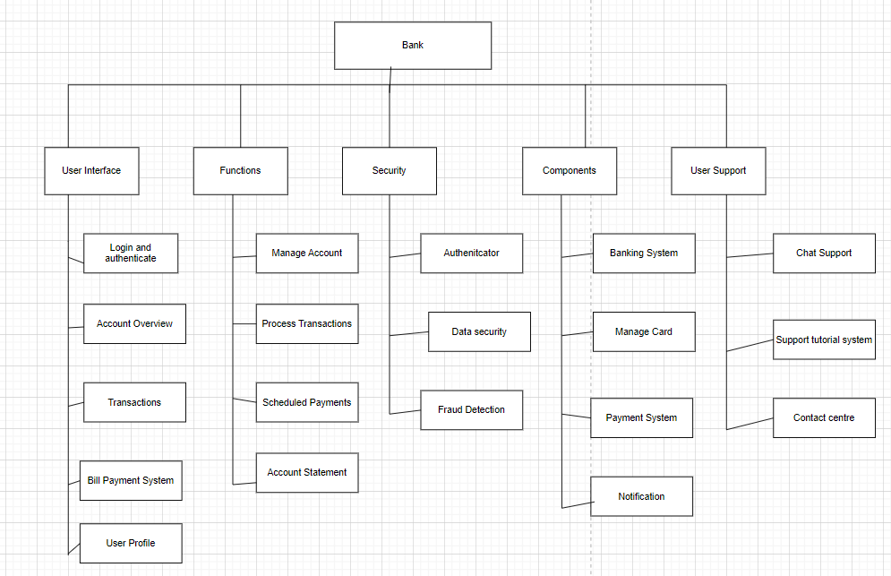
Figure 4 - Product Breakdown Structure for Digital Banking Platform
The anchor of the PBS is the bank as it is the root element and branches into five major categories. Each category breaks down into specific components that form the complete digital banking solution. User interface covers customer-based elements, functions handle core banking operation, security section addresses protection mechanisms, components represent technical systems and user support providing customer assistance.

2c) Describe technologies involved in the process to create the I.T. deliverable in the previous item. Explain how (i) inspection, (ii) testing and (iii) validation, would have been used to establish the correctness of that I.T. deliverable. That is give one example of specific parts of the process where it would have been natural for each of these techniques to be applied.

The technologies needed to design Digital Banking Platform Development:
- Mobile and Web Development Frameworks:
- React used for mobile applications development
- Node.js used for backend development
- Database:
- MYSQL for storing data
- MongoDB to store session data
- Security:
- JSON Web Tokens for user authentication
- Cloud Hosting Technologies:
- Amazon Web Services to host mobile services and databases
- Payment Integration:
- Use Visa Direct to process payments
Inspection: Specific Example: Review code of user authentications

- Experienced developers review the code to see if it is vulnerable and manage sensitive information.
- The inspection process will use a checklist to ensure the code follows security practices.
- Taking place during development phase before the code is implemented into system and give time if any flaws are found to be redesigned.
Testing: Specific Example: Test units for payment transfer
- Unit testing used for different functions in transferring money, such as validating receipt information, calculating transactions and initiating the transfer.
- Automated testing tools to test component and create function using JavaScript.
- Test different scenarios, such as how to handle invalid account numbers or insufficient funds and ensure system behaves accordingly under all conditions.

3. Validation: Specific Example: User Acceptance Testing on mobile banking app
- User Acceptance Testing (UAT) will be used with a group of banking customers, they will interact with mobile application and do activities such as checking balances and transferring funds.
- Focus on quality of interface and how well the application performs under conditions such as latencies issues or system crashes.
- Feedback gathered through surveys to track the error amount and time taken to complete tasks.
- This helps the application become user friendly and meet customer needs.

Using inspection, testing, validations help the digital banking platform is up to standard with a high-quality code, secure and reliable functionality. The aim is to meet the expectations of both the business and the end users before deployment.

3a) Consider a third scenario. This scenario has to focus on usability, as perceived by the end-users (an important part of any product). Assume your team is asked to improve the usability of a deliverable/product you considered in your previous scenarios, and you are given six months to achieve it. Identify which is/are the function/s to be improved in the product and the goals that are to be achieved in order to enhance its usability. Usability can depend on various underlying quality attributes, choose two quality attributes and express a plan to improve them by using Planguage notation (Specifically the subset of Planguage parameters: Tag, Description, Scale of Measure, Past and Goal). [ An example of the required Planguage notation is as follows: Expressing the quality attribute ‘Speed’ for a car Tag: Speed. Description: Speed of a specially designed car for Project PQR. Scale of Measure: Average speed over {defined distance} when driven by {defined driver type; default: experienced F2 racing driver} in miles per hour. Past (Silverstone, 5 miles, July 2022): 250 <- Chief Engineer. Goal (Silverstone, 5 miles, July 2023): 300 <- Chief Engineer. ] Make any assumptions necessary when writing the Planguage quality attributes. You will need to provide the metric values (that is, in the example above, the values 250 and 300) that are appropriate for your chosen usability quality attribute and these will have to be created by you. Any reasonable metric values will be acceptable, you are not expected to research realistic metric values! (10 marks)

Function to improve: Digital mobile banking platform to enhance user experience.
Objective 1: Improve User Interface
- Redesign the banking application screens and prioritise important functions (account balance, money transfers).
- Design must be consistent across different devices (tablets) with a responsive layout that automatically adjust screen sizes.
- Suitable font sizes, ensure standards are accessible for users with any impairments.
- Implement default patterns based on user behaviour.
- Introduce dashboard to which users personalise banking experience.
Objective 2: Improve Navigation
- Design a navigation bar with access to core banking functions (accounts, payments, card) to reduce navigation depth.
- Introduce automatic controls for common actions (swipe between accounts, pull down to refresh balances, etc).
- Create a search function that allows users to quickly locate specific transactions, payees or banking services.
- Develop a help system to guide user’s needs.
- Create saved payee templates and implement predictive text input for common transaction.
- Provide shortcuts to the users most frequent banking activities.

Addressing attribute (using Planguage notation):
Quality Attribute 1: Usability
  - Tag: Usability
  - Description: Simplistic interface in mobile banking application
  - Scale of Measure: The steps needed to make a payment transfer to a friend
  - Past: 10 steps needed to transfer money (March 2025)
  - Goal: 5 steps to transfer money (September 2025)
Quality Attribute 2: Reactivity (Performance)
  - Tag: Reactivity
  - Description: The time taken for banking application to respond to user action (e.g. user wants to check past transactions)
  - Scale of Measure: How many seconds on average it takes to view past transactions.
  - Past: 5 seconds on average (March 2025)
  - Goal: 2.5 seconds (September 2025)

By improving these important attributes, it will make the application more responsive and user friendly for users, this will lead to a higher level of satisfaction within the business.

3b) Select one root cause that you have identified in Question 3a) and treat it as a risk (a threat to the project’s success). Document this risk using the PRINCE2 risk template ensuring that you specify suitable countermeasures. Indicate which countermeasure(s) you would recommend and explain why you think the recommended countermeasure(s) would address the risk. (10 marks)
Root Cause Identified: The root cause identified is a delayed response within mobile banking application that leads to a dissatisfied user.
PRINCE2 Risk Template:
- Risk Title: Slow Leading Time in Banking Applications
- Risk Description: The mobile banking application delays in function such as viewing account balance can increase user stress and totally abandon the application. This is because the user may be ready to make a payment but needs to quickly check if they have enough money to transfer.
- Likelihood: Very High because this can affect retaining users and ruin the brand image.
- Impact: High because dissatisfaction can lead to complaints, reduced customer loyalty and lower ratings in reviews.
Countermeasures
- Backend Code: Review and optimize backend systems to reduce latency.
- Fast database queries: Implement databases techniques to speed up queries for checking account balances.
- Caching: Cache user data to reduce need for repetition in database.
- Testing: Run tests to control user traffic and identify any issues within performance.

Recommended Countermeasures

I would recommend optimizing backend code and adopting fast database queries as the key countermeasures. These measures address underlying causes of slow loading times and they can be implemented with minimal impact. These countermeasures will improve application performance and enhance user satisfaction.

3c) For the organization and main process of your case study, indicate what the CMMI maturity level would be, justify your answer. (10 marks)
The aim of the bank is to improve customer service, security and operational efficiencies.
CMMI Maturity Level: 3 (Defined)
Justification: The process is well documented.
Process: The bank has a clear system for developing, deploying and maintaining the digital banking platform. These include designing a mobile application, instilling security protocols and ensuring it is compliant with regulations. There is a well-documented WBS that outlines steps in system analysis, development, testing, deployment and depicts a structure to the project.
Documentation and Quality Assurance: The project includes designing user interfaces, improving performances, finalizing transactions, which all require documentation and management. Testing processes ensure the platform meets bank requirements and user needs, the use of a product breakdown structure and a clear strategy shows a well-organized and systematic approach.
Regulatory Compliance: The system is developed and ensures it is compliant with all government regulations; this approach shows the bank meets legal needs which is a key characteristic of a level 3 maturity organization.
Project consistency: The use of standardized approach in WBS, detailed planning and scheduling, clear alignment with customer and regulatory requirements indicate that processes are not ad hoc but are applied in the project lifecycle.
Monitoring Performance: This project includes post-implementation reviews, customer feedback analysis, and a focus on performance tracking, which aligns with CMNI Level 3 focus on improvement and process management. The bank is not only concerned with the initial deployment but is also focused on improving the system based on user feedback and performance.
To conclude, the bank’s transformation project falls under Level 3: Defined in CNMI as the business is well defined, standardized process that ensure consistency across quality project. These processes are well documented and actively followed to achieve regulatory compliance, operational efficiencies and satisfy customers that all are key characteristics of a level 3 maturity organization.

